Vending Machine Data Administrator – Project Report
Date: 24-10-2025
Prepared By: Medidha Sivaji
Dataset Used: VendingMachine_Refill_Operations_10k.csv

1. Executive Summary
This report documents the complete process of designing a database, cleaning and analyzing vending machine operational data, and developing a Power BI dashboard to visualize key performance metrics. The objective was to evaluate data handling, analysis, and dashboard development capabilities using real-world vending machine refill and sales data. It covers database schema design, anomaly detection and cleaning, exploratory analysis, and dashboard creation.

2.Project Overview & Objectives
- Design a normalized relational database schema to efficiently store and query operational data.
- Clean the dataset and handle anomalies (missing, duplicate, or invalid entries).
- Perform exploratory data analysis to uncover patterns in refills, sales, and machine utilization.
- Develop an interactive Power BI dashboard showing KPIs such as revenue trends, refill frequency, and machine uptime.
- Document all findings, methodologies, and visual insights professionally.

3. Database Setup & Schema Design
The first step involved creating a normalized relational database to efficiently manage and query vending machine operations data. The dataset was imported into MySQL, and tables were designed following the principles of 3NF normalization.
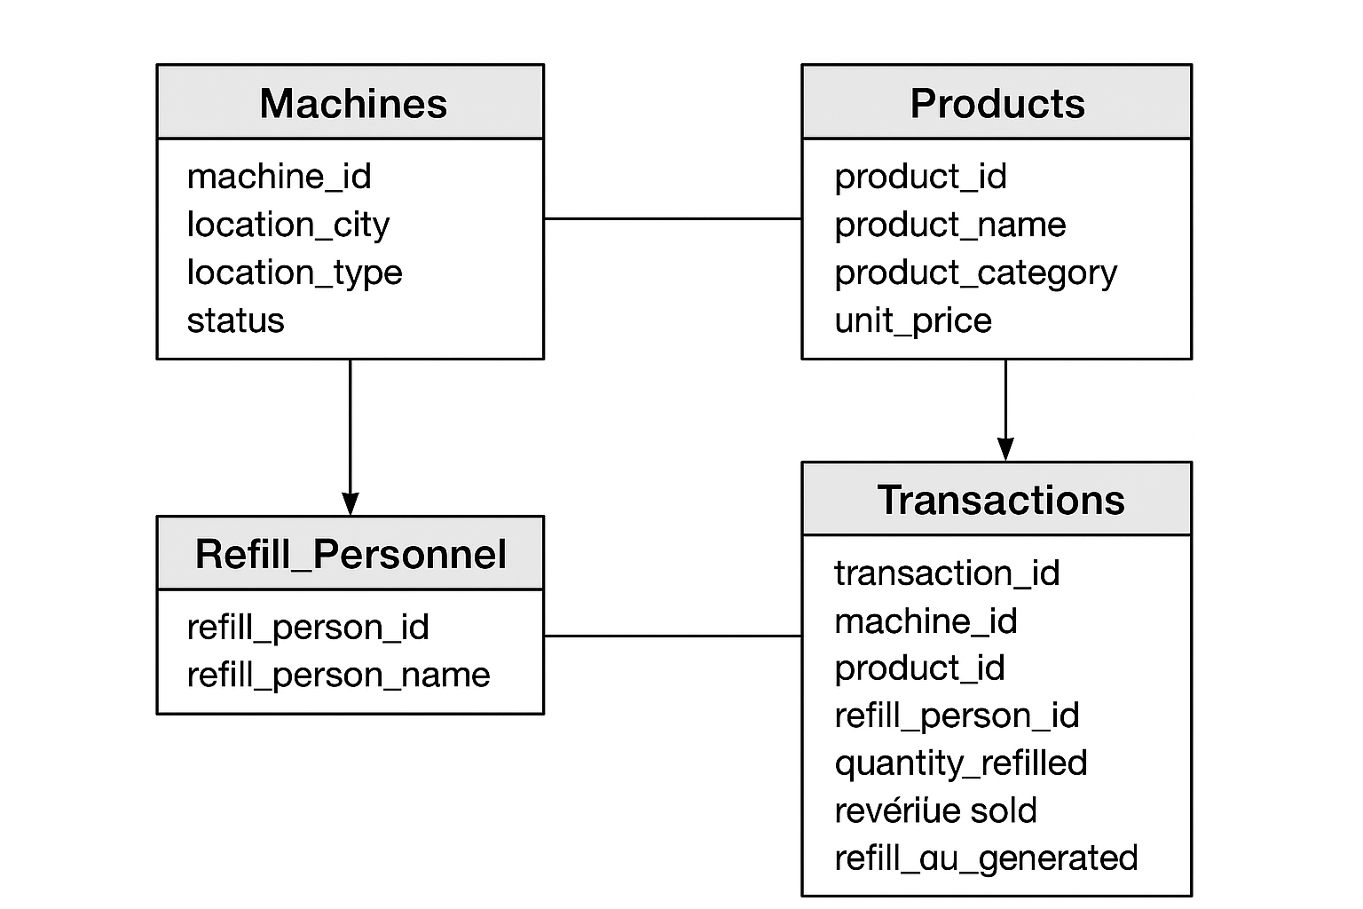

Example SQL Schema:
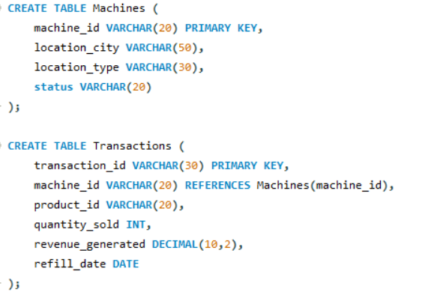

Data import was handled using MySQL Workbench's data import wizard. Basic data validation queries were executed to check record consistency and data integrity.

4. Data Cleaning & Preprocessing
Data cleaning was conducted using Python (Pandas and NumPy). Missing values, duplicates, and negative quantities were identified and corrected.
Example Python Code:
python
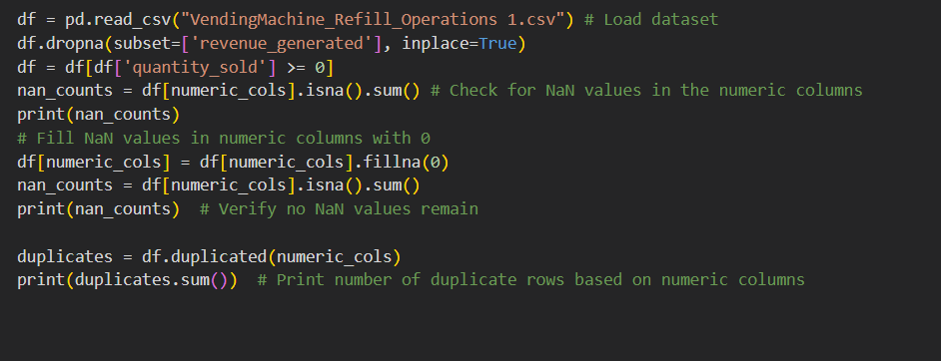

5.Exploratory Data Analysis & Insights
Exploratory Data Analysis (EDA) was performed to understand sales trends, refill frequencies, product performance, and operational efficiency. Insights were visualized using Power BI and Python (Matplotlib).
Key metrics analyzed:
- Monthly revenue trend
- Machine downtime vs revenue impact.

Monthly Revenue Trend:
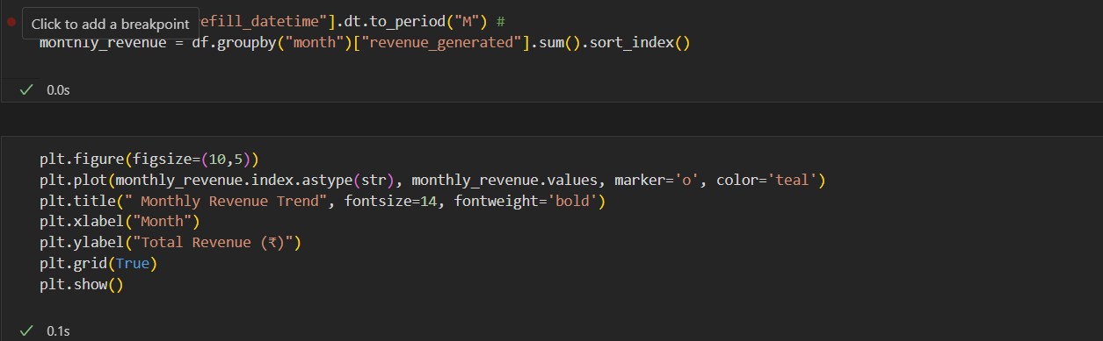

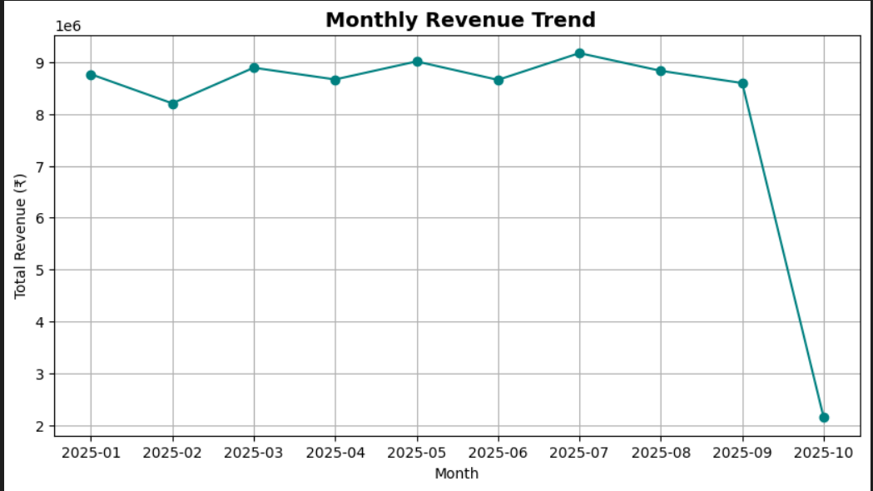

Machine downtime vs revenue impact.
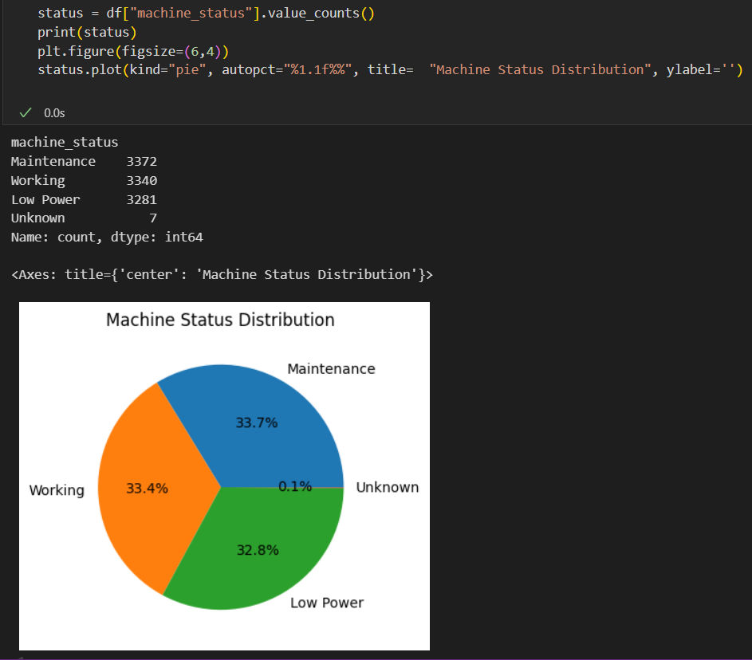
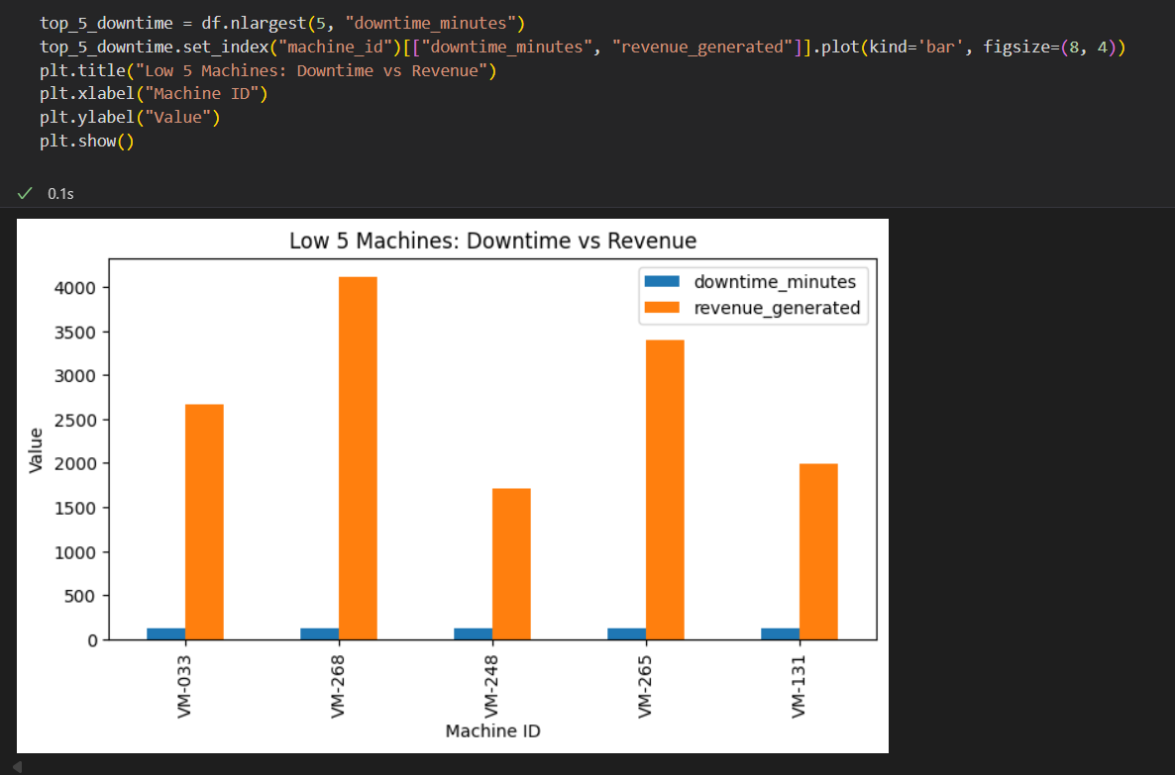

6. Dashboard Development
A dynamic Power BI dashboard was developed to visualize key vending machine KPIs. The dashboard connects to the cleaned data source and updates automatically on data refresh.
Key KPIs and Visuals:
- Total Revenue
- Average Customer Rating
- Machine Uptime Percentage
- Refill Frequency
- Top Performing Cities & Products
Interactive slicers were added for city, product category, and time period selection.
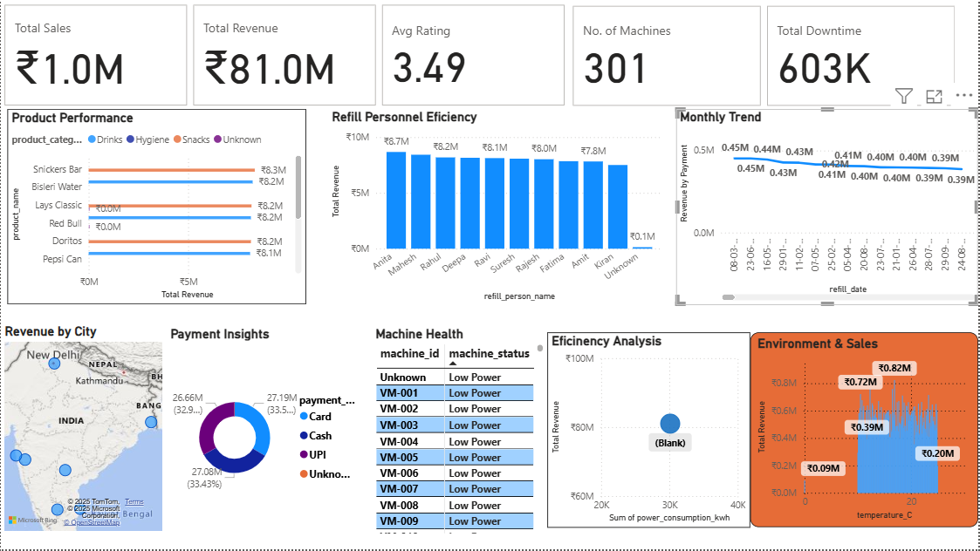

7. Results & Insights
- Machines in metropolitan cities generate approximately 40% higher revenue compared to smaller towns.
- Drinks category is the most profitable, contributing to nearly 55% of total sales.
- Machines with frequent maintenance logs show 25% lower uptime and 30% less revenue.
- Refill personnel efficiency directly correlates with machine uptime and consistent revenue generation.

8. Challenges & Solutions
Challenge 1: Missing Refill Person Data
Solution: Filled using median values grouped by machine_id and location.
Challenge 2: Mixed Date Formats
Solution: Standardized all refill dates using Pandas to_datetime() conversion.
Challenge 3: Power BI Data Refresh Delays
Solution: Optimized Power BI model relationships and reduced unnecessary columns.

9. Tools & Technologies Used
Database: MySQL
Data Cleaning: Python, Pandas, NumPy
Visualization: Power BI, Matplotlib
Reporting: Power BI Export

10. Conclusion & Recommendations
The Vending Machine Data Analysis project successfully demonstrated data management, analysis, and visualization capabilities. The developed Power BI dashboard provides valuable operational insights for decision-makers. Future improvements could include integrating real-time IoT data streams and automating Power BI refresh workflows.
- Integrate live IoT data for real-time vending machine monitoring.
- Enhance Power BI automation with scheduled refresh and alerts.
- Develop machine performance prediction using ML algorithms.

